1.

2.

3.

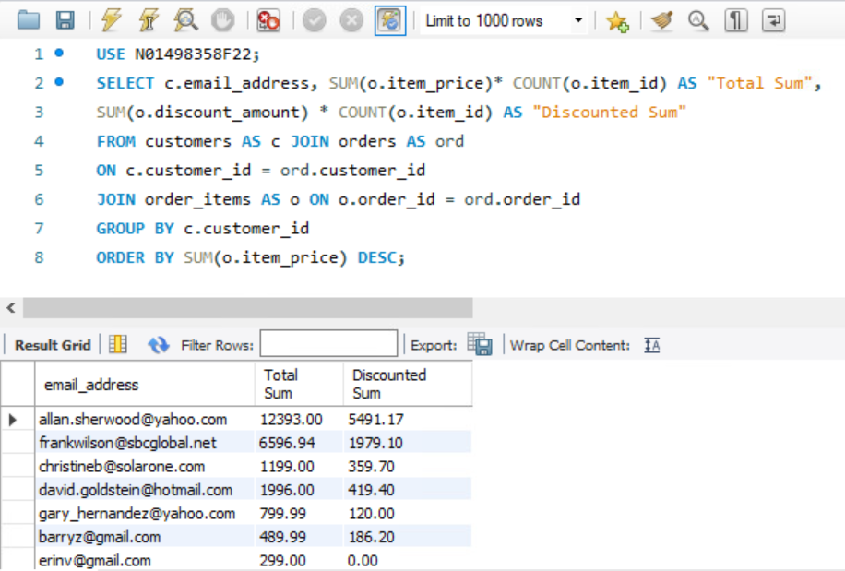

4.

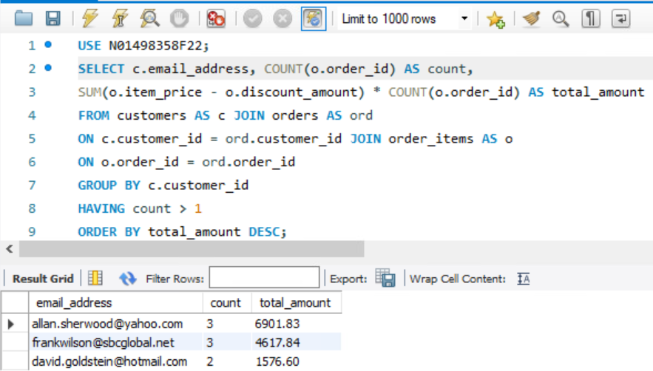

5.

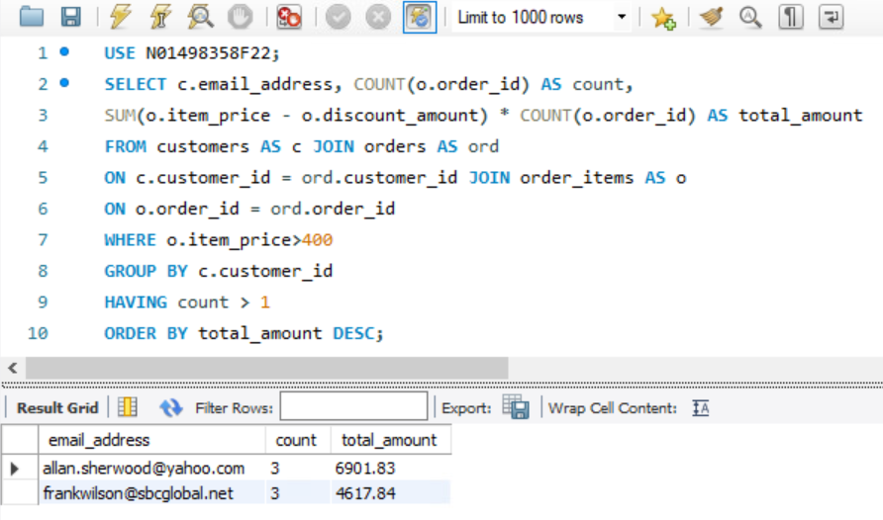

6.

7.

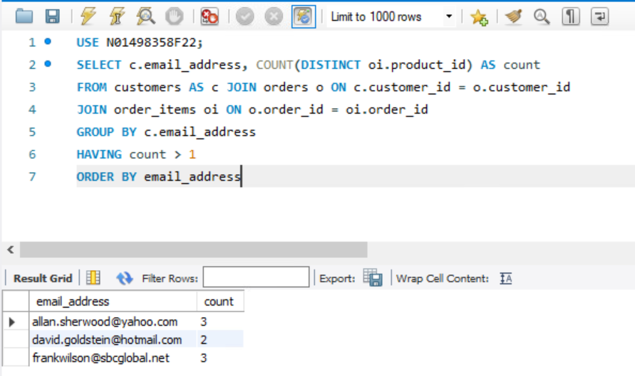

8.

